**Food Spoilage**

We often see that the[food](https://www.toppr.com/guides/science/food-where-does-it-comes-from/sources-of-food/) that has been kept out for too long, smells foul and looks rotten. But what causes this? What will happen if we eat this food? Is it edible? Let’s find out more about Food Spoilage.

Suggested Videos

Food Preservation

Food Spoilage

Food Preservation

**Introduction**

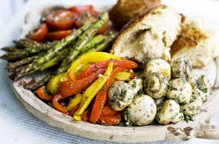*Spoiled food (Source: mademags)*

If food items are kept for a long period of time and not stored properly, they get spoil such food items are bad for [health](https://www.toppr.com/guides/biology/human-health-and-diseases/health-and-diseases/). When food items kept for a long time gets spoil as germs start growing on it. Once the food is spoiled, it cannot be eaten and has to be thrown away. Spoilage is a process in which food items deteriorate to the point in which it is not edible to [human](https://www.toppr.com/guides/esssays/human-rights-essay/).

**Causes of Spoilage**

The food and [water](https://www.toppr.com/guides/chemistry/hydrogen/water/) may be infected by germs. Flies carry germs. When they sit on our food, they pass on these germs to our food. There are various factors which are responsible for food spoilage such as bacteria, mould, yeast, moisture, [light](https://www.toppr.com/guides/physics/light-reflection-and-refraction/), [temperature](https://www.toppr.com/guides/physics/thermal-properties-of-matter/temperature-and-heat/), and [chemical reaction](https://www.toppr.com/guides/chemistry/chemical-reactions-and-equations/chemical-reactions-and-equations/).

**1. Bacteria**

They are the most abundant[microorganisms](https://www.toppr.com/guides/biology/microorganisms/microorganisms-and-its-uses/) found on the [earth](https://www.toppr.com/guides/essays/essay-on-save-earth/). They are tiny in size and vary in [shape](https://www.toppr.com/guides/maths/shapes-and-angles/intro-shapes-and-angles/). Some bacteria are useful also. They help to convert milk into curd.

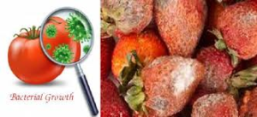*Bacteria growth (Source: femininetouchblog)*

**2. Protozoa**

They are single-celled [microorganisms](https://www.toppr.com/guides/biology/microorganisms/microorganisms-and-its-uses/) that cause [disease](https://www.toppr.com/guides/biology/human-health-and-diseases/types-of-diseases/) like food poisoning etc.

**3. Fungi**

They are found in damp and warm places and grow on the dead and rotting matter.

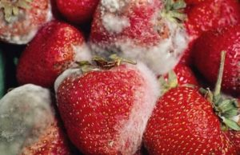*Fungi (Source: sciencedaily)*

**4. Temperature**

Temperature is one of the major factors which is responsible for food spoilage.

**Signs of food spoilage**

Signs of food spoilage include an appearance different from the fresh food, such as a change in color, a change in texture, an unpleasant odor or taste.

**Activity I**

* Aim: To study the growth of fungus.
* [Materials](https://www.toppr.com/guides/science/sorting-materials-into-groups/properties-of-materials/): Piece of bread
* [Method](https://www.toppr.com/guides/business-management-and-entrepreneurship/human-resource-management/methods-of-training/): Take a piece of bread. Make it moist and keep it in a warm corner of the room for 3-4 days. Observe it after 3-4 days.
* Observation: Presence of greenish patch growing on the bread.

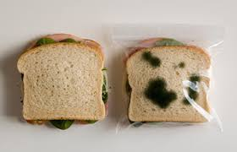*(Source: i2-prod.mirror)*

**Food Preservation**

Food is valuable**.** Preserving food can help to avoid wasting of food. Food preservation involves preventing the food from being spoilt. Preservation of food is the process by which food is stored by special methods. Cooked or uncooked food can be preserved in different ways to be used later. Some methods of preservation are:

**1. Freezing**

Food kept in a refrigerator remains fresh for some days. Germs do not grow easily in cool places. We preserve food items, like milk fruit, vegetables and cooked food by keeping them in a refrigerator.

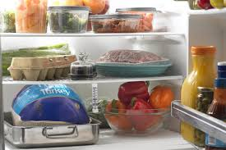*Method of freezing (Source: skinnycentral)*

**Activity II**

* Aim: To understand the principle of food preservation.
* Materials: Two apples, fridge
* Method: Take two apples. Keep one apple in the fridge and one outside for 2-3 days. Record your observation.
* Observation: The apple inside the fridge is fresh while the one outside will start decaying.

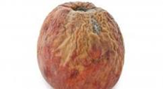*(Source: food.onehowto)*

**2. Boiling**

By this method, we can preserve food for a short period of time. Germs in milk are killed by pasteurization. It is done by boiling milk for sometimes and then cooling it quickly.

**3. Salting**

We can add salt to preserve pickles and fish.

**4. Sweetening**

Excess sugar in food also acts as a preservative. We store food for a long time in the form of jams, jellies, and murabbas by adding sugar.

**5. Dehydration**

In this method, the food items are dried in sun to stop the growth of bacteria in them. Certain foods, like[raw mangoes](https://www.toppr.com/guides/evs/mangoes-round-the-year/mangoes/), fishes, potato chips and papads are preserved by this method.

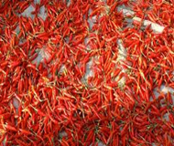*(Source: amazonaws)*

**6. Canning**

In this method, air is removed from food and put in airtight cans so that germs do not grow on them. Food items like vegetables, seafood, dairy [products](https://www.toppr.com/guides/business-studies/marketing/product/) etc. Are preserved through this method.

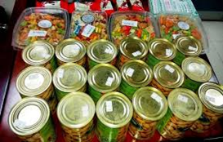*canning*

**Advantages and Disadvantages**

* **Advantages of food preservation**: Germs do not grow easily in preserved food and make it safe to eat. Preservation enables us to enjoy seasonal fruits like strawberries and mangoes even during the offseason.
* **Disadvantages of food preservation:** Excess salt and sugar are used in the preservation of food which is not good for health. Some methods of food preservation may lead to loss of [nutrients](https://www.toppr.com/guides/science/nutrition-in-animals/introduction-to-nutrition/).

**Solved Example**

Q1. What is food spoilage?

Ans:  Food spoilage means the colour, flavour, taste, texture and nutritional value of a food is unsuitable and not edible to human.

Q2. What are the various methods of preserving food?

Ans:  The  various methods of food preservation are:

* Refrigeration: a low temperature of the fridge does not allow germs to grow, thus food is preserved. ex, vegetables, eggs and fruits.
* Drying: Water is removed by heating or evaporation. Ex grain and pulses.
* Pickling: Addition of salt and spices. Ex mango, lemon, vegetables.
* Deep freezing: Keeping food, vegetables, meat and fish in the freezer for a long period.
* Canning: Addition of sugar to make jam, jelly and sauces etc.
* Airtight pouches: Keeping prepared food items in [nitrogen](https://www.toppr.com/guides/biology/mineral-nutrition/metabolism-of-nitrogen/) or gas-filled poly pack pouches. Example – chips, French fries, noodles etc.

Q3. Write down disadvantages of preservation.

Answer: Excess salt and sugar is used in the preservation of food which is not good for health. Some methods of food preservation may lead to loss of nutrients.